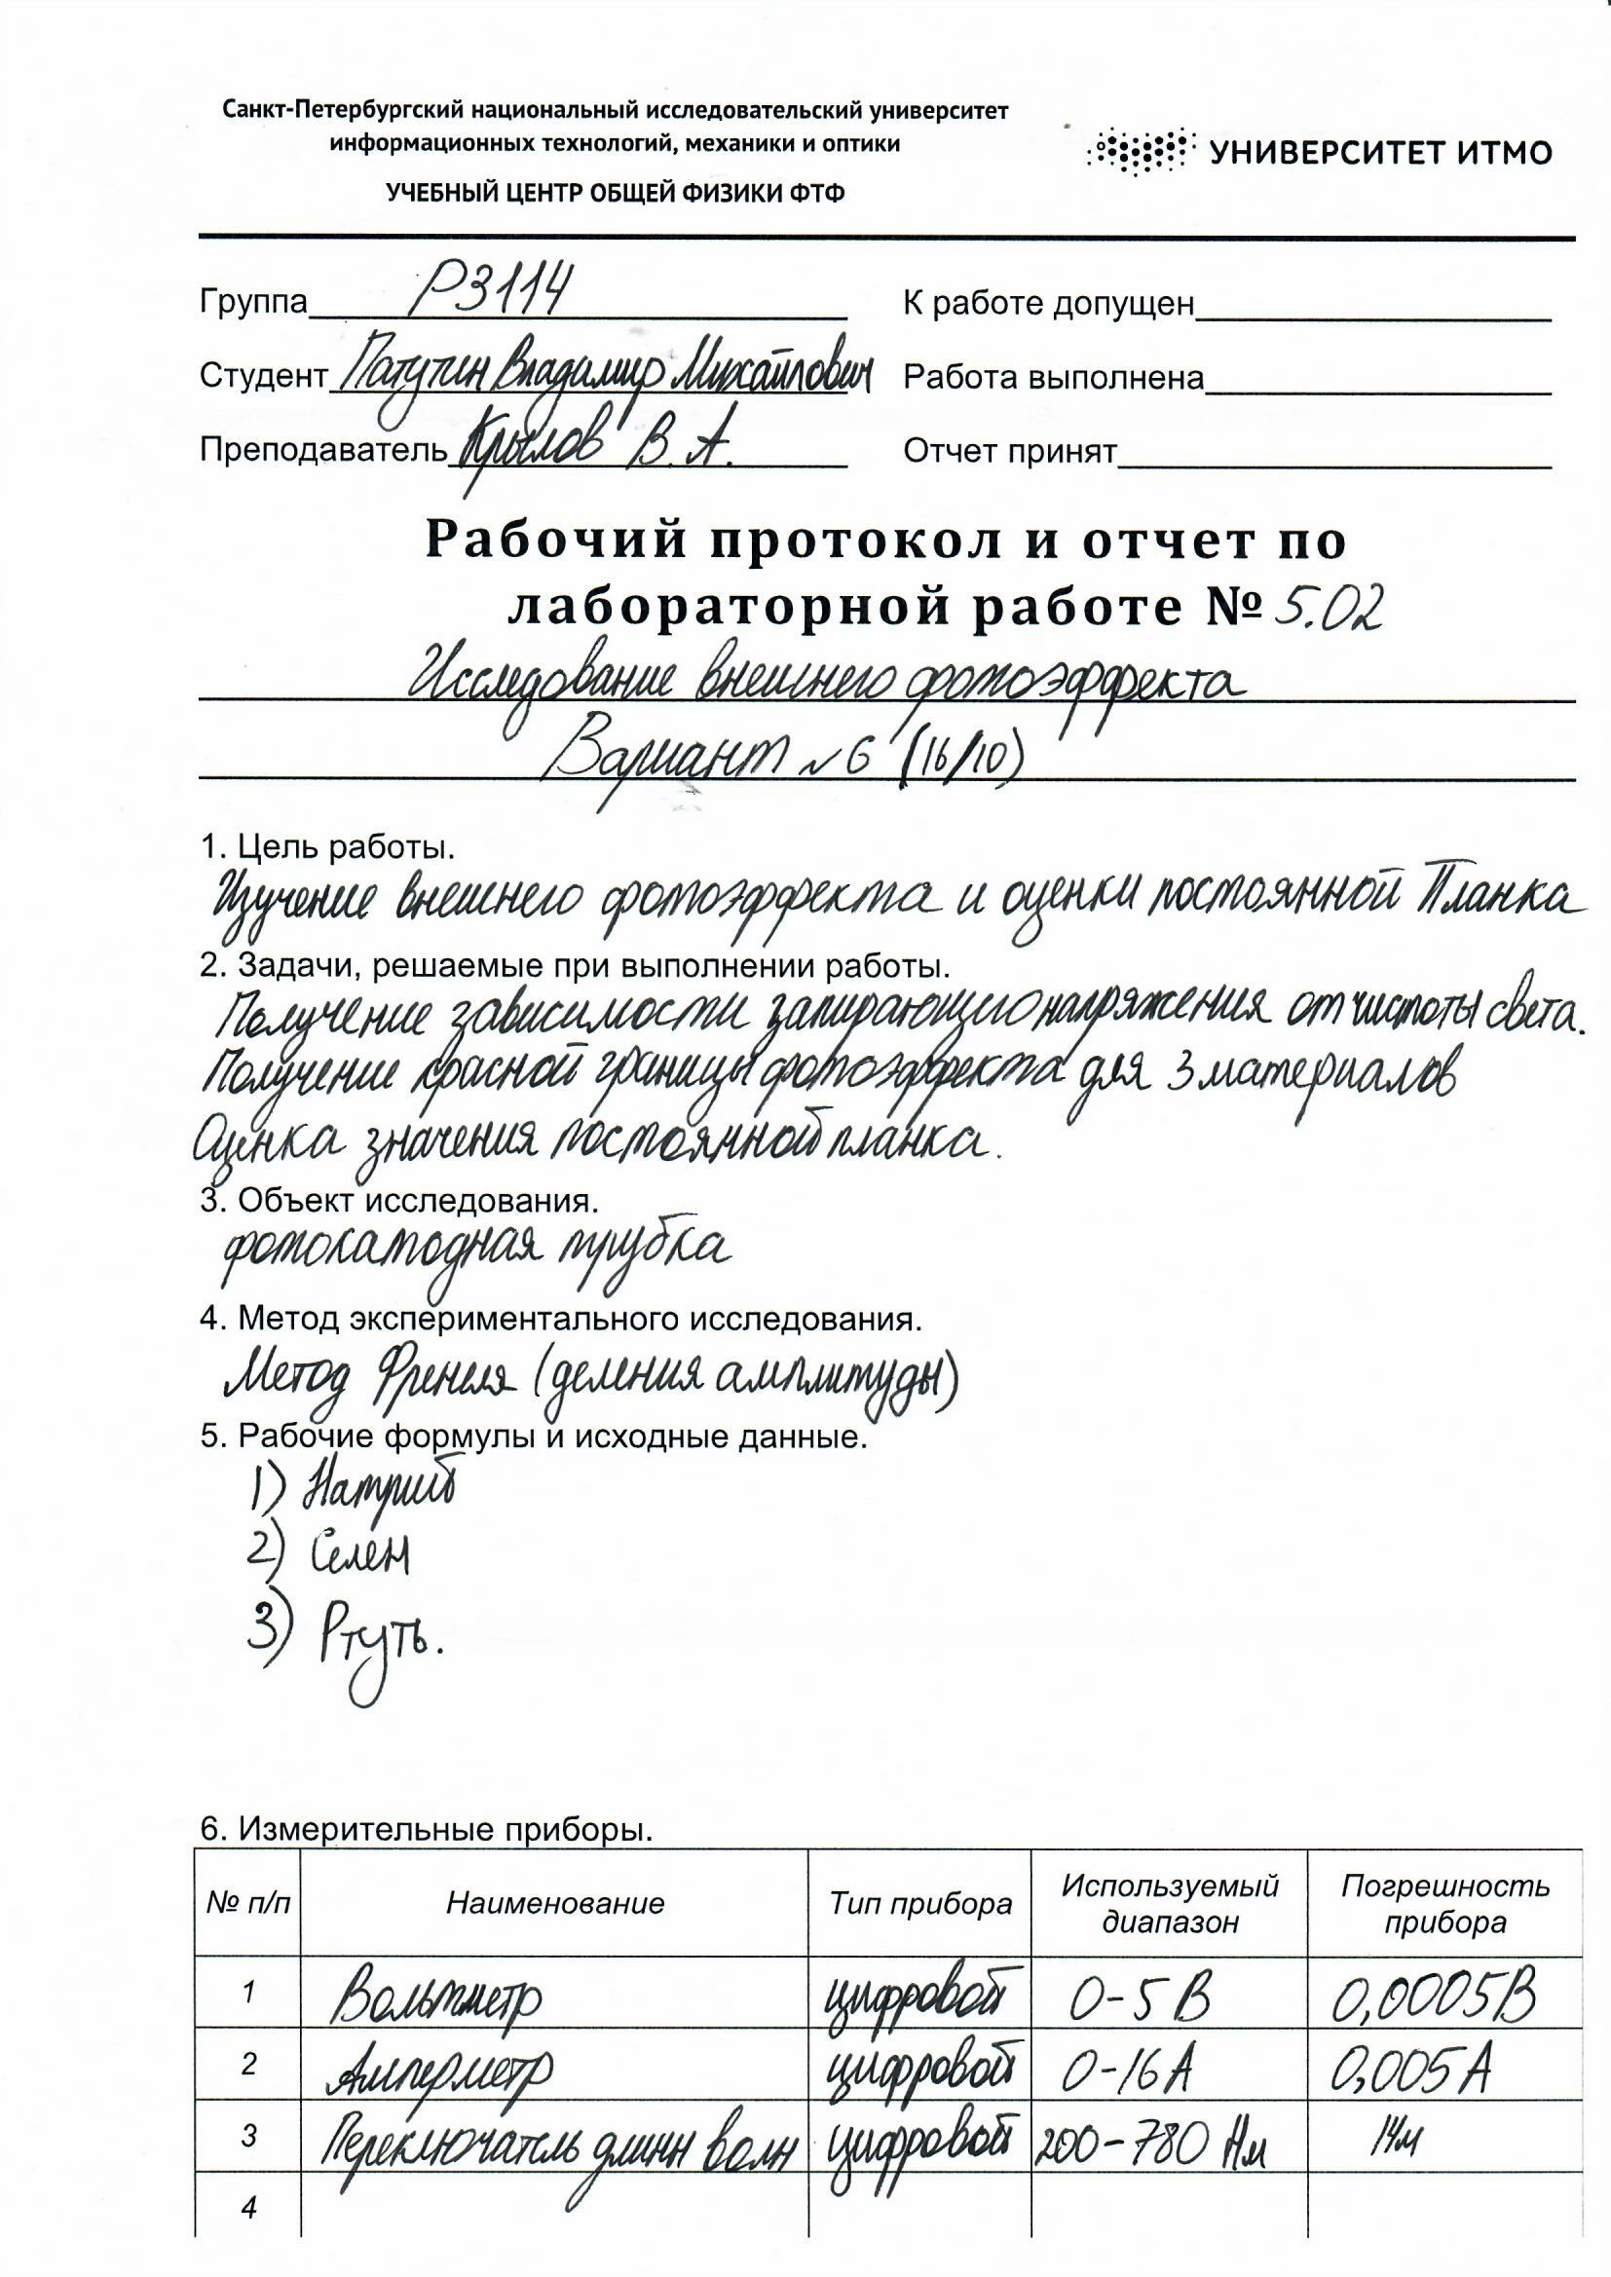

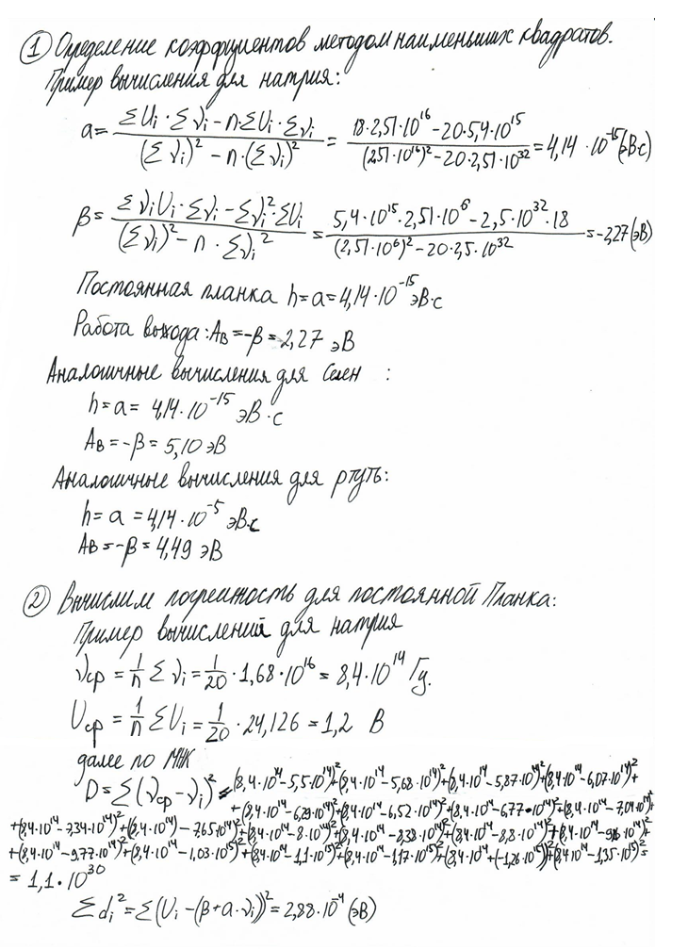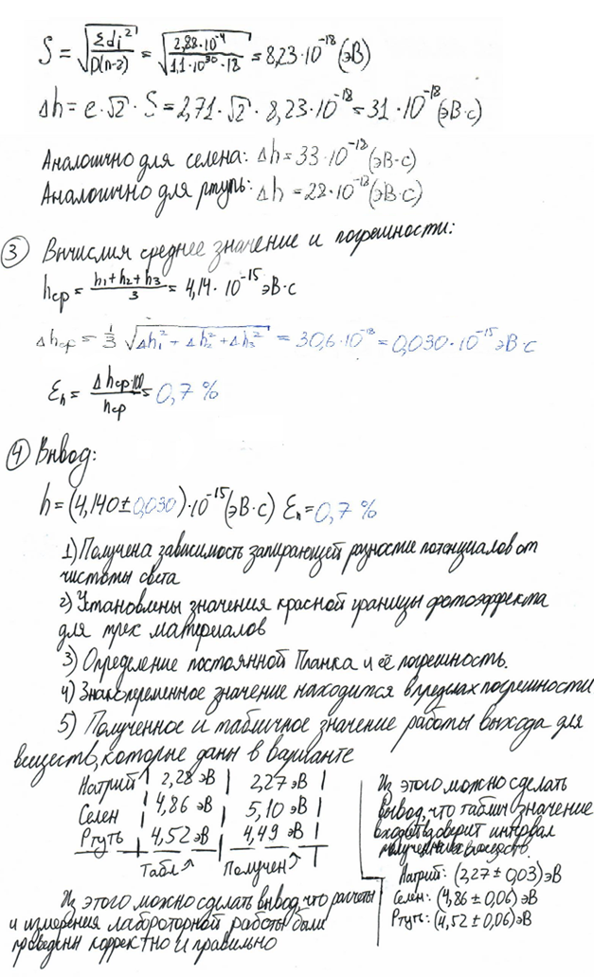

**Схема установки**

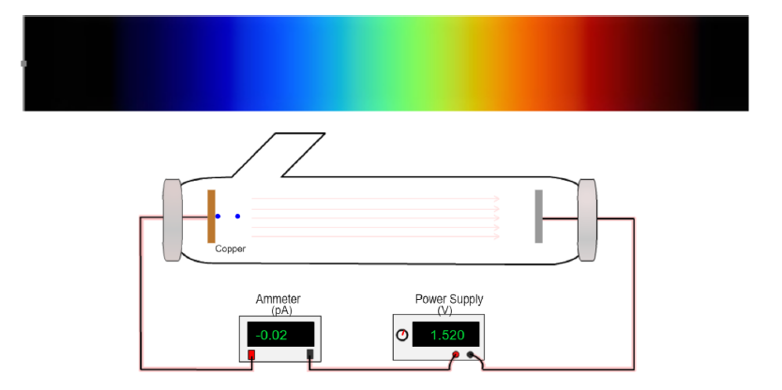

**Результат тестирования**

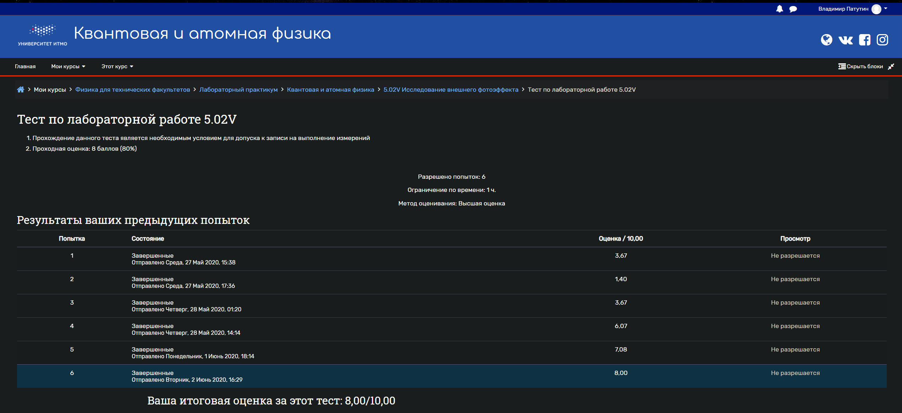

**Полученные таблицы измерений**

1.Натрий (λкр = 545 нм)

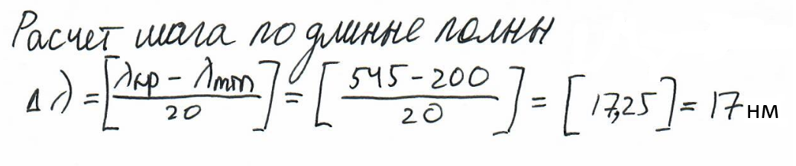

|  |  |  |  |  |  |
| --- | --- | --- | --- | --- | --- |
| Trial | Metal | Voltage (V) | Current (pA) | Frequency (Hz) | Wavelength (nm) |
| 1 | Sodium | 0.010 | 0.00 | 5.5046E14 | 545.00 |
| 2 | Sodium | 0.080 | 0.02 | 5.6818E14 | 528.00 |
| 3 | Sodium | 0.159 | 0.01 | 5.8708E14 | 511.00 |
| 4 | Sodium | 0.240 | -0.01 | 6.0729E14 | 494.00 |
| 5 | Sodium | 0.328 | 0.01 | 6.2893E14 | 477.00 |
| 6 | Sodium | 0.432 | 0.01 | 6.5217E14 | 460.00 |
| 7 | Sodium | 0.530 | -0.01 | 6.7720E14 | 443.00 |
| 8 | Sodium | 0.639 | -0.01 | 7.0423E14 | 426.00 |
| 9 | Sodium | 0.761 | 0.02 | 7.3350E14 | 409.00 |
| 10 | Sodium | 0.889 | 0.01 | 7.6531E14 | 392.00 |
| 11 | Sodium | 1.038 | -0.01 | 8.0000E14 | 375.00 |
| 12 | Sodium | 1.199 | -0.02 | 8.3799E14 | 358.00 |
| 13 | Sodium | 1.380 | 0.01 | 8.7977E14 | 341.00 |
| 14 | Sodium | 1.562 | 0.02 | 9.2593E14 | 324.00 |
| 15 | Sodium | 1.769 | 0.01 | 9.7720E14 | 307.00 |
| 16 | Sodium | 2.010 | -0.01 | 10.3448E14 | 290.00 |
| 17 | Sodium | 2.278 | 0.02 | 10.9890E14 | 273.00 |
| 18 | Sodium | 2.582 | 0.00 | 11.7188E14 | 256.00 |
| 19 | Sodium | 2.919 | 0.03 | 12.5523E14 | 239.00 |
| 20 | Sodium | 3.321 | 0.02 | 13.5135E14 | 222.00 |

2.Селен (λкр = 243 нм)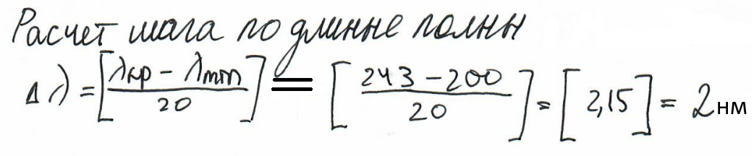

|  |  |  |  |  |  |
| --- | --- | --- | --- | --- | --- |
| Trial | Metal | Voltage (V) | Current (pA) | Frequency (Hz) | Wavelength (nm) |
| 1 | Selenium | 0.012 | 0.02 | 12.3457E14 | 243.00 |
| 2 | Selenium | 0.049 | -0.01 | 12.4481E14 | 241.00 |
| 3 | Selenium | 0.099 | -0.01 | 12.5523E14 | 239.00 |
| 4 | Selenium | 0.139 | 0.02 | 12.6582E14 | 237.00 |
| 5 | Selenium | 0.182 | 0.00 | 12.7660E14 | 235.00 |
| 6 | Selenium | 0.230 | 0.00 | 12.8755E14 | 233.00 |
| 7 | Selenium | 0.280 | 0.00 | 12.9870E14 | 231.00 |
| 8 | Selenium | 0.320 | -0.01 | 13.1004E14 | 229.00 |
| 9 | Selenium | 0.371 | -0.02 | 13.2159E14 | 227.00 |
| 10 | Selenium | 0.422 | 0.00 | 13.3333E14 | 225.00 |
| 11 | Selenium | 0.471 | -0.01 | 13.4529E14 | 223.00 |
| 12 | Selenium | 0.521 | 0.00 | 13.5747E14 | 221.00 |
| 13 | Selenium | 0.571 | 0.00 | 13.6986E14 | 219.00 |
| 14 | Selenium | 0.618 | 0.00 | 13.8249E14 | 217.00 |
| 15 | Selenium | 0.679 | -0.02 | 13.9535E14 | 215.00 |
| 16 | Selenium | 0.729 | 0.00 | 14.0845E14 | 213.00 |
| 17 | Selenium | 0.790 | 0.00 | 14.2180E14 | 211.00 |
| 18 | Selenium | 0.840 | -0.01 | 14.3541E14 | 209.00 |
| 19 | Selenium | 0.899 | -0.01 | 14.4928E14 | 207.00 |
| 20 | Selenium | 0.958 | 0.02 | 14.6341E14 | 205.00 |

3.Ртуть (λкр = 276 нм)

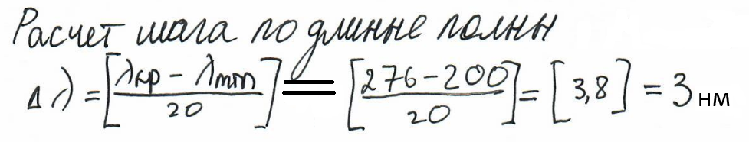

|  |  |  |  |  |  |
| --- | --- | --- | --- | --- | --- |
| Trial | Metal | Voltage (V) | Current (pA) | Frequency (Hz) | Wavelength (nm) |
| 1 | Mercury | 0.010 | 0.02 | 10.8696E14 | 276.00 |
| 2 | Mercury | 0.061 | -0.01 | 10.9890E14 | 273.00 |
| 3 | Mercury | 0.109 | 0.01 | 11.1111E14 | 270.00 |
| 4 | Mercury | 0.160 | 0.02 | 11.2360E14 | 267.00 |
| 5 | Mercury | 0.211 | -0.01 | 11.3636E14 | 264.00 |
| 6 | Mercury | 0.268 | 0.02 | 11.4943E14 | 261.00 |
| 7 | Mercury | 0.319 | 0.00 | 11.6279E14 | 258.00 |
| 8 | Mercury | 0.379 | 0.02 | 11.7647E14 | 255.00 |
| 9 | Mercury | 0.441 | 0.02 | 11.9048E14 | 252.00 |
| 10 | Mercury | 0.499 | 0.00 | 12.0482E14 | 249.00 |
| 11 | Mercury | 0.559 | 0.00 | 12.1951E14 | 246.00 |
| 12 | Mercury | 0.618 | 0.00 | 12.3457E14 | 243.00 |
| 13 | Mercury | 0.679 | 0.00 | 12.5000E14 | 240.00 |
| 14 | Mercury | 0.751 | 0.02 | 12.6582E14 | 237.00 |
| 15 | Mercury | 0.821 | -0.02 | 12.8205E14 | 234.00 |
| 16 | Mercury | 0.890 | -0.01 | 12.9870E14 | 231.00 |
| 17 | Mercury | 0.961 | -0.01 | 13.1579E14 | 228.00 |
| 18 | Mercury | 1.030 | 0.01 | 13.3333E14 | 225.00 |
| 19 | Mercury | 1.100 | -0.01 | 13.5135E14 | 222.00 |
| 20 | Mercury | 1.180 | -0.01 | 13.6986E14 | 219.00 |

**График зависимости запирающего напряжения от частоты**

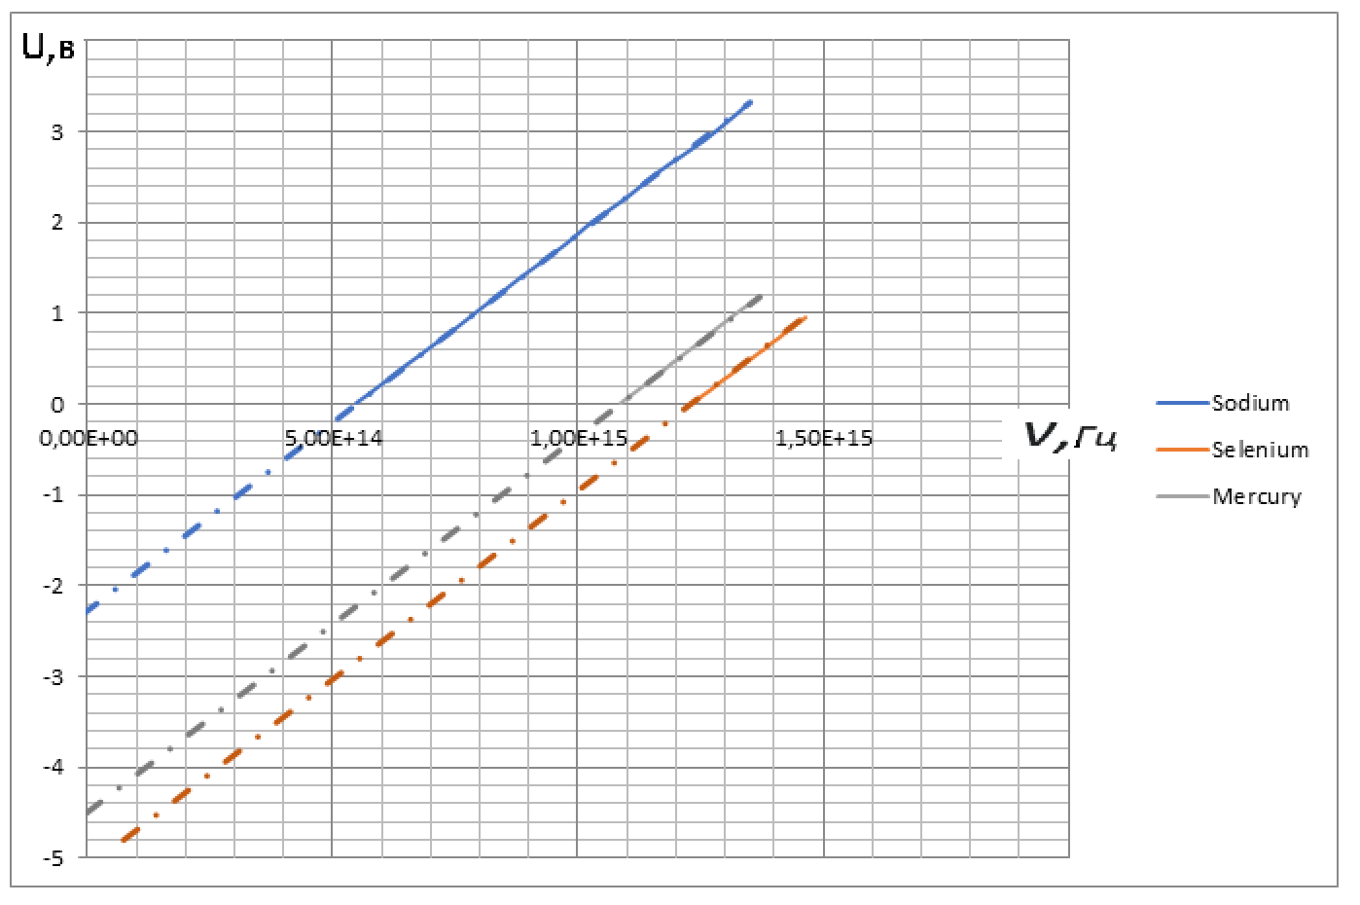

*y = ax + β, x = 0, y = β*